Foundations of Reading Open-Response Item Assignment:
Scoring for assignment will be based on the rubric from http://www.ms.nesinc.com/Content/STUDYGUIDE/SA_SG_CRI_FOR.htm

Subarea I—Foundations of Reading Development
0003 Understand the role of phonics in promoting reading development.
- For example: explicit strategies for teaching phonics; the role of phonics in developing rapid, automatic word recognition; the role of automaticity in developing reading fluency; interrelationships between decoding, fluency, and reading comprehension; the interrelationship between letter-sound correspondence and beginning decoding (e.g., blending letter sounds); strategies for helping students decode single-syllable words that follow common patterns (e.g., CVC, CVCC, CVVC, CVCe) and multisyllable words; methods for promoting and assessing the use of phonics generalizations to decode words in connected text; use of semantic and syntactic clues to help decode words; the relationship between decoding and encoding (e.g., analyzing the spellings of beginning readers to assess phonics knowledge, using spelling instruction to reinforce phonics skills); strategies for promoting automaticity and fluency (i.e., accuracy, rate, and prosody); the relationship between oral vocabulary and the process of decoding written words; specific terminology associated with phonics (e.g., phoneme, morpheme, consonant digraph, consonant blend); and development of phonics skills and fluency in individual students (e.g., English Language Learners, struggling readers through highly proficient readers).
0004 Understand word analysis skills and strategies.
- For example: development of word analysis skills and strategies in addition to phonics, including structural analysis; interrelationships between word analysis skills, fluency, and reading comprehension; identification of common morphemes (e.g., base words, roots, inflections and other affixes); recognition of common prefixes (e.g., un-, re-, pre-) and suffixes (e.g., -tion, -able) and their meanings; knowledge of Latin and Greek roots that form English words; use of syllabication as a word identification strategy; analysis of syllables and morphemes in relation to spelling patterns; techniques for identifying compound words; identification of homographs (i.e., words that are spelled the same but have different meanings and may be pronounced differently [e.g., bow, part of a ship/bow, to bend from the waist; tear, a drop of water from the eye/tear, to rip]); use of context clues (e.g., semantic, syntactic) to help identify words and to verify the pronunciation and meaning of words; and development of word analysis skills and fluency in individual students (e.g., English Language Learners, struggling readers through highly proficient readers).

Subarea II—Development of Reading Comprehension
0005 Understand vocabulary development.
- For example: the relationship between oral and written vocabulary development and reading comprehension; the role of systematic, noncontextual vocabulary strategies (e.g., grouping words based on conceptual categories and associative meanings) and contextual vocabulary strategies (e.g., paraphrasing); the relationship between oral vocabulary and the process of identifying and understanding written words; strategies for promoting oral language development and listening comprehension (e.g., read-alouds, word explanation strategies); knowledge of common sayings, proverbs, and idioms (e.g., raining cats and dogs, better safe than sorry); knowledge of foreign words and abbreviations commonly used in English (e.g., RSVP); criteria for selecting vocabulary words; strategies for clarifying and extending a reader's understanding of unfamiliar words encountered in connected text (e.g., use of semantic and syntactic clues, use of word maps, use of the dictionary); strategies for promoting comprehension across the curriculum by expanding knowledge of academic language, including conventions of standard English grammar and usage, differences between the conventions of spoken and written standard English, general academic vocabulary, and content-area vocabulary (e.g., focus on key words); the importance of frequent, extensive, varied reading experiences in the development of academic language and vocabulary; and development of academic language and vocabulary knowledge and skills in individual students (e.g., English Language Learners, struggling readers through highly proficient readers).

Due Dates
Open Response #1: October 18,
Open Response #2: November 10
Open Response #3: December 1

Purpose: The purpose of this assignment is to help candidates learn to write open-response items at the highest level of the Foundations Reading Test scoring scale.

Overview
Candidates will write three (150-200 word) responses. They must format their responses using the four criteria outlined in the Sample Open-Response Item Assignment (access link above for a description of each criteria):
1. Purpose
2. Subject knowledge
3. Support
4. Rationale
Directions
1. Before you begin, read and study the example of an open-response found at the link listed above.

2. Study the “Key” at the bottom of oral reading passages # 2 and #3 and learn how marks are used to record errors and missteps. Then read the excerpt from the child’s oral reading performance. Oral reading passage #1 does not have a key. Instead, you are to study the marks made by the reviewer within the text of the passage.

3. Use selected skills and concepts from specified objectives 0003, 0004, and 0005 to identify one strength and one weakness on the student’s use of word identification strategies
4. Write a 150-200 word (about a half page single spaced) response about the student’s word identification strategies. Be sure to cite specific evidence from the information shown in the passage to support your response. Format your response to address each of the four criteria listed above and described in the Study Guide on Open-Response Items (see link at top of page).

5. For Open-Response #1, you must site information from objective 0003. For Open-Responses #4 and #5, you must cite information from objectives 4 and 5. Write the objectives and the specific related skills and concepts you addressed at the bottom of your open-response. Simply copy and paste the objectives and specific related skills from this document. This list of objective/s and related skills and concepts do not count as part of your 150-200 word response.

6. Before turning in your assignment, check your work with the Scoring Scale to make sure you have written at the level of “4.”

Open-Response Assignment #1

Kayla, a second grade student reads aloud a passage from an unfamiliar story. As she reads, the teacher notes her performance on a separate copy of the story. Printed below is an excerpt from the teacher’s record of Kayla’s oral reading performance.

Write an open-response based on objective 0003 in which you:
Identify one of Kayla’s strengths and one of Kayla’s weaknesses in using letter-sound correspondences, decoding single syllable words that follow common patterns (e.g. CVC, CVCC, CVVC, CVCe), multiple syllable words, phonics generalizations, and use of semantic or syntactic clues to help decode words. Be sure to cite evidence from the passage in your explanation of the strengths and weaknesses.

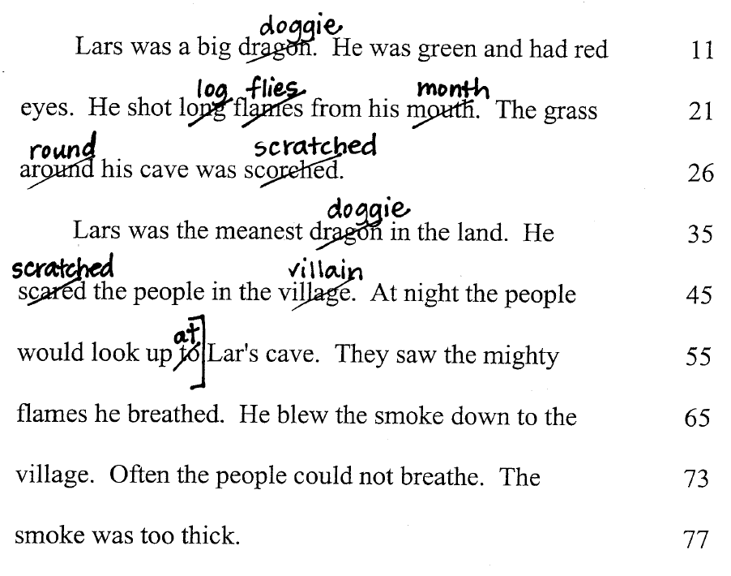
Open Response Assignment #2

Tonya, a 3rd grade student reads aloud a passage from an unfamiliar story. As she reads, the teacher notes her performance on a separate copy of the story. Printed below is an excerpt from the teacher’s record of Kayla’s oral reading performance.

Write an open-response based on objectives 0004 and 0005 in which you:
Identify one of Tonya’s strengths and one of Tonya’s weaknesses related to the objectives. Be sure to cite evidence from the passage in your explanation of the strengths and weaknesses.

The Oral Reading Passage about Shonda and her father is on the following page. Be sure to study the key at the bottom of the passage before reading and analyzing Tony’s oral reading skills.
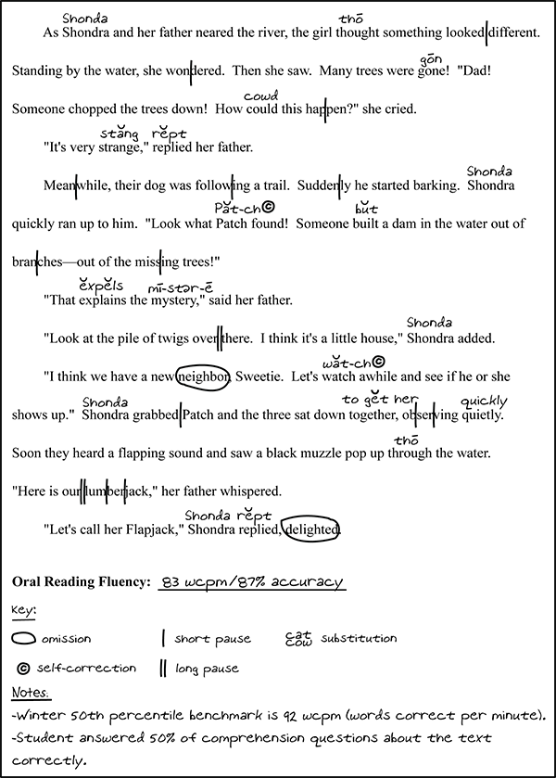

Open Response Assignment #3

Elmer, a 4th grade student reads aloud a passage from an unfamiliar story. As he reads, the teacher notes his performance on a separate copy of the story. Printed below is an excerpt from the teacher’s record of Elmer’s oral reading performance.

Write an open-response based on objectives 0004 and 0005 in which you:
Identify one of Elmer’s strengths and one of Elmer’s weaknesses related to the objectives. Be sure to cite evidence from the passage in your explanation of the strengths and weaknesses.

Study the key at the bottom of the passage before reading and analyzing Elmer’s oral reading skills.

